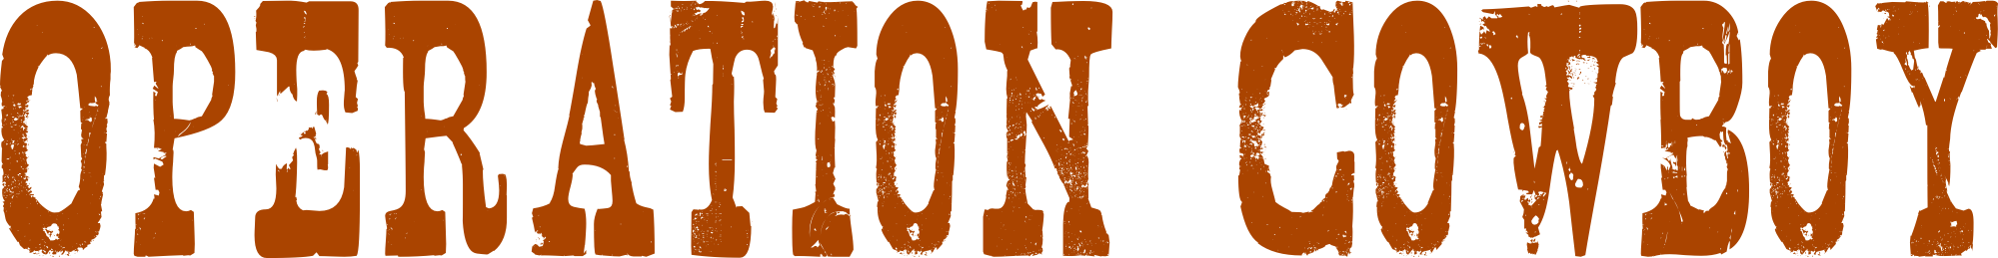
http://wiki.openstreetmap.org/wiki/Operation_Cowboy

You are interested in drawing maps and GPS? We trace aerial imagery a whole night long and try to get the United States even better for OpenStreetMap. Support us if you like, it's pretty easy!
You need just a Laptop and a computer mouse, we will teach you the rest :)

When? 23. November at 06:00pm

Where? xxxx
(describe the way)

Wer? http://wiki.openstreetmap.org/wiki/xxx



