HowTo proofread a text in weeklyOSM

1. Login here: http://www.weeklyosm.eu/wp-login.php?
Please login with the data an administrator sent in the email to you.

2. You should arrive here:
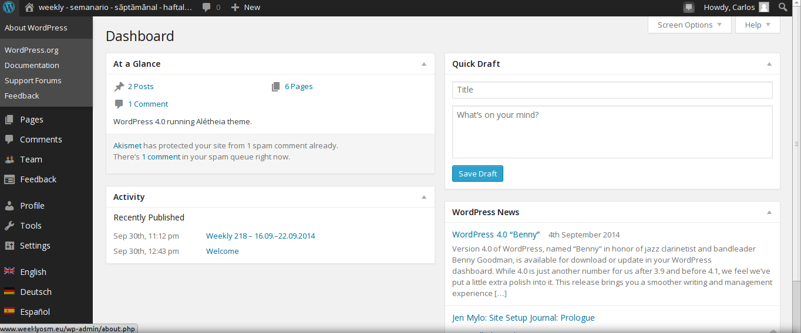
3. You click on the flag of your language on the lower left
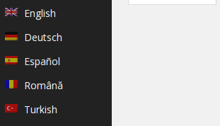

4. You can see, that the Desktop switched to your language like here
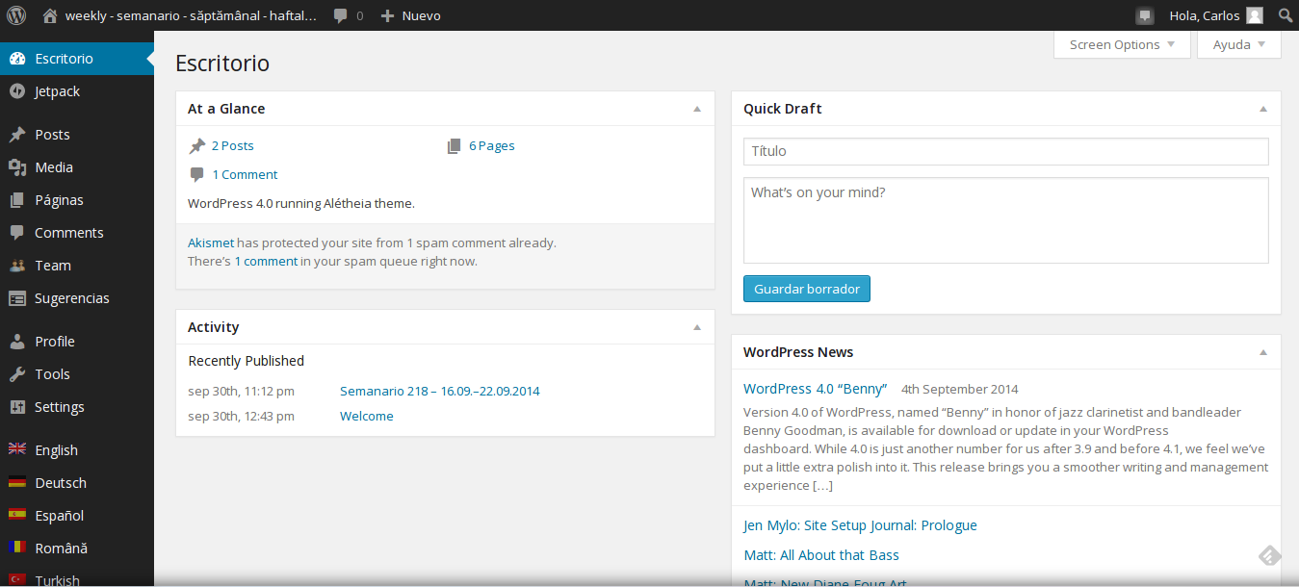
I will continue in the English version. ;-)

5. You choose: Pages – All Pages and you arrive here:

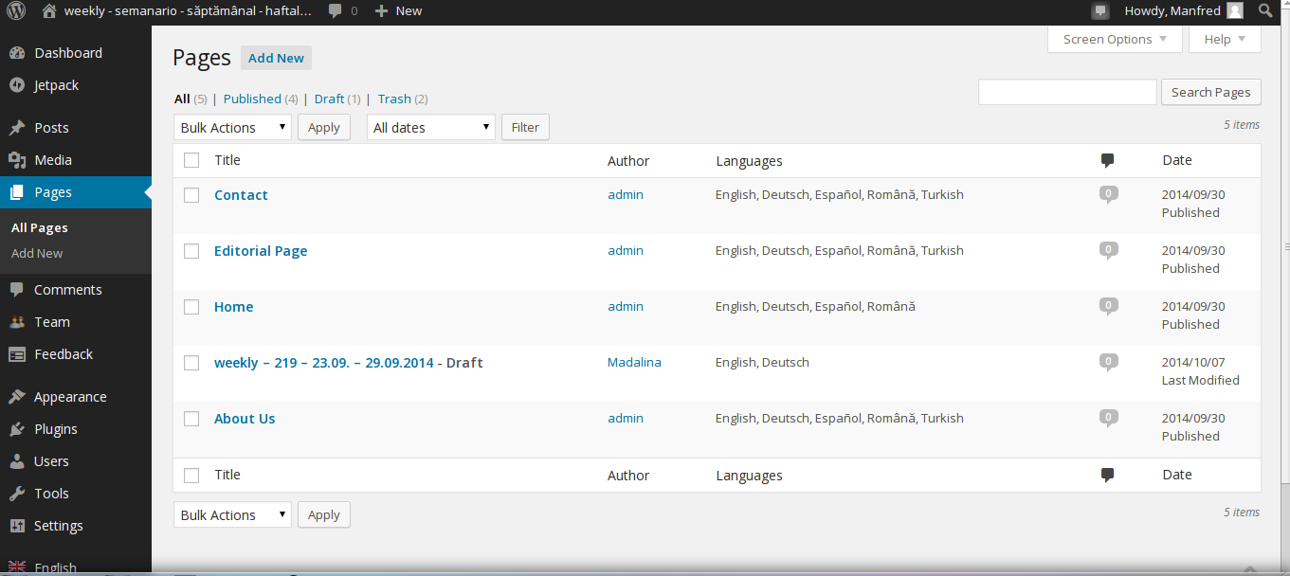
You see the weekly to proofread

6. As you will now proofread the 219, you click here, please. Result:

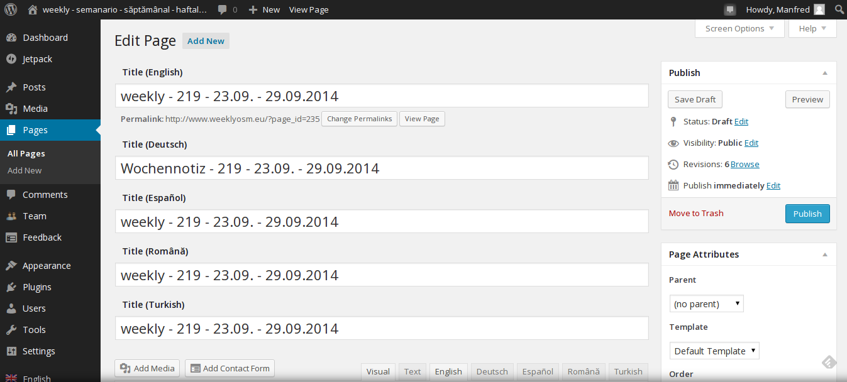

7. Clicking this tab, you choose your language for proofreading. ;-)

8. If an other language is highlighted, you click your language and start proofreading, ;-)

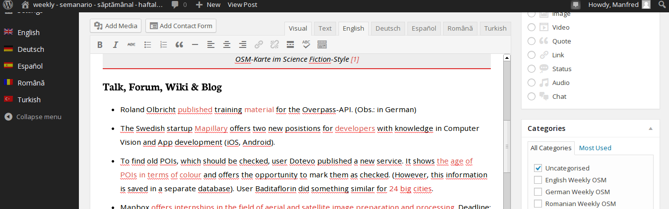
You see, I have choosen English. ...and … You can start the proofreading right now!
Please do corrections directly in the text.

Don't forget to press from time to time the „Save Draft“ button.
You can use as often as you like the „Preview“ button as well.

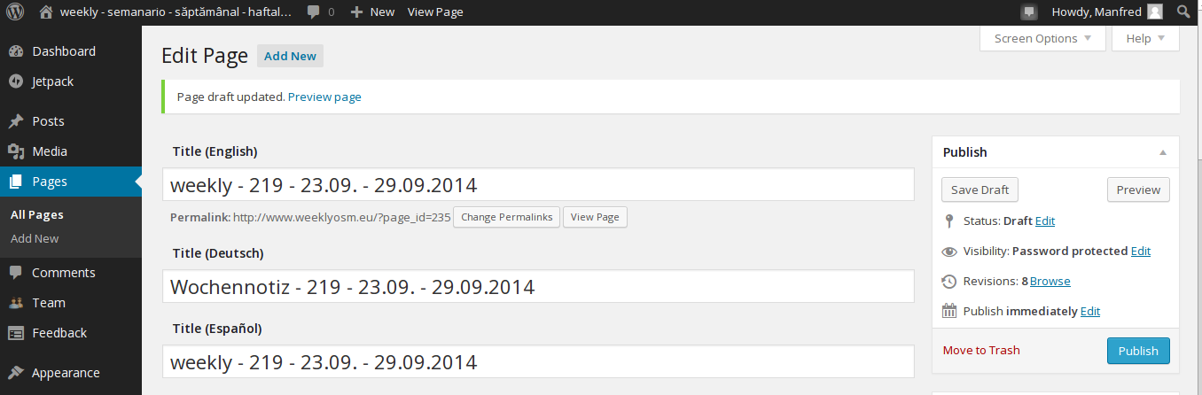
Please NEVER use the Publish button.
Publishing will be done in the POST area. ;-)

Don't forget to push the Save Draft button. Then you can logout here.

Any question – don't hesitate to ask:
ma [dot] reiter [at] gmail [dot] com
or
madalinaionescu79 [at] gmail [dot] com

Have a lot of fun.

MychOSM - The steering committee
2014/10/07

